**Project Report**

**Name:** Vamsi Krishna Chakravartula

**SID:** 014488487

**Youtube link:** [**https://youtu.be/UJZwhEUJqhA**](https://youtu.be/UJZwhEUJqhA)

o Introduction: State your goals and purpose of the system

1.Purpose of the project:

The prototype was designed with the intention to replicate a portion of the Yelp website with the restaurants, customers and reviews in focus. There are ordering features provided along with the reviewing sections

2. System design:

The system includes 3 layers with the frontend done in React, backend using express and node and the database using MySQL. All the components were deployed on the aws cloud platform using the EC2 instances and the RDS database service available.

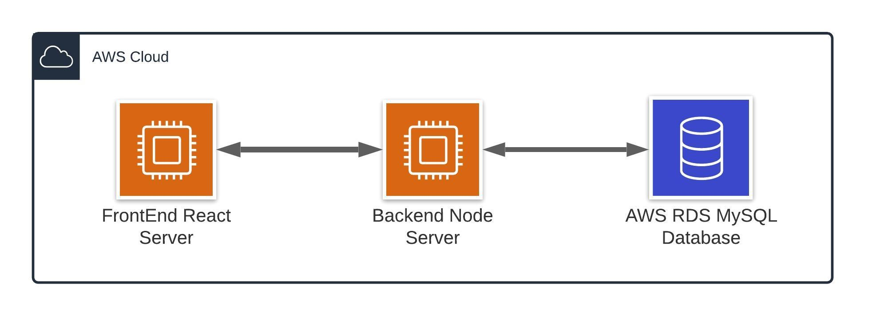

o Results: Screen captures of testing results and important screens of the application.

Restaurant Home:

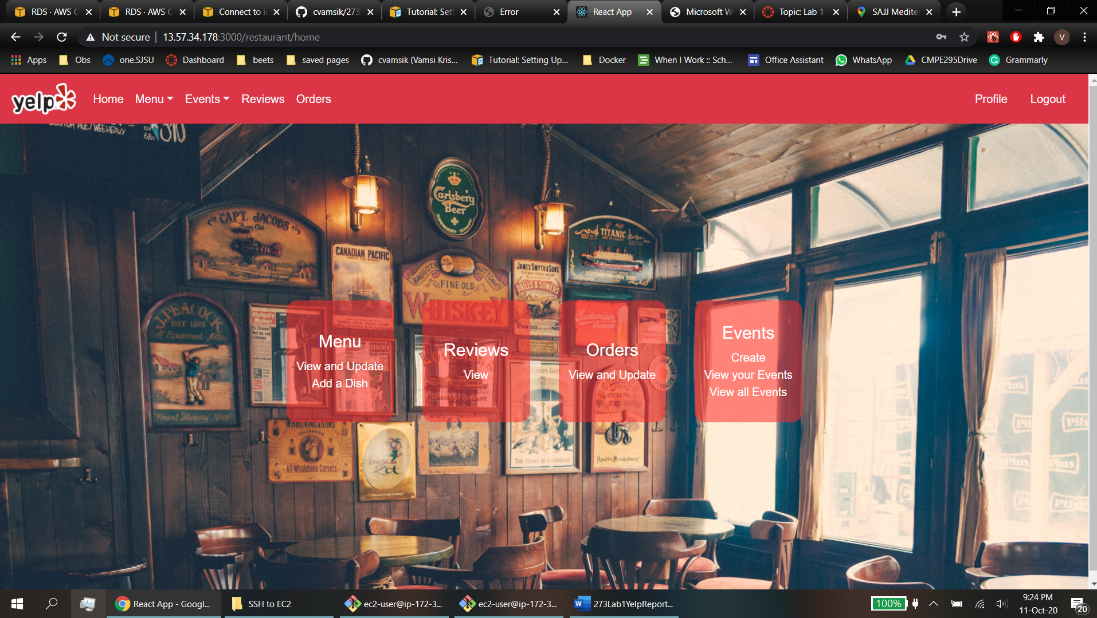

Dish Creation

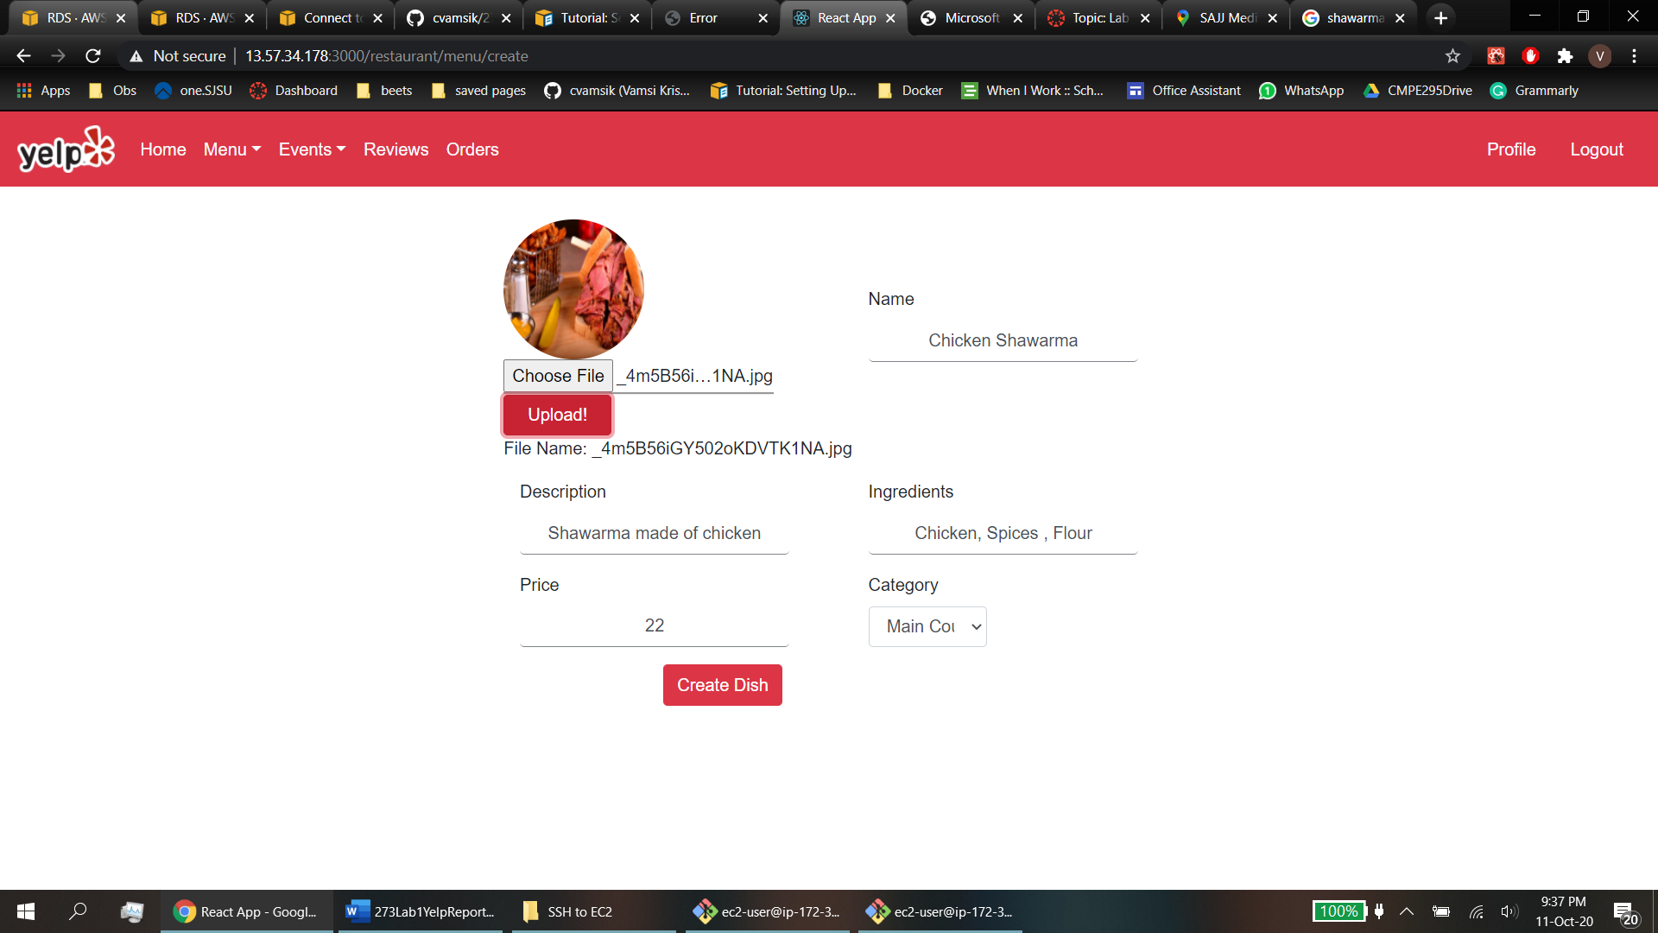

Restaurant Edit Menu:

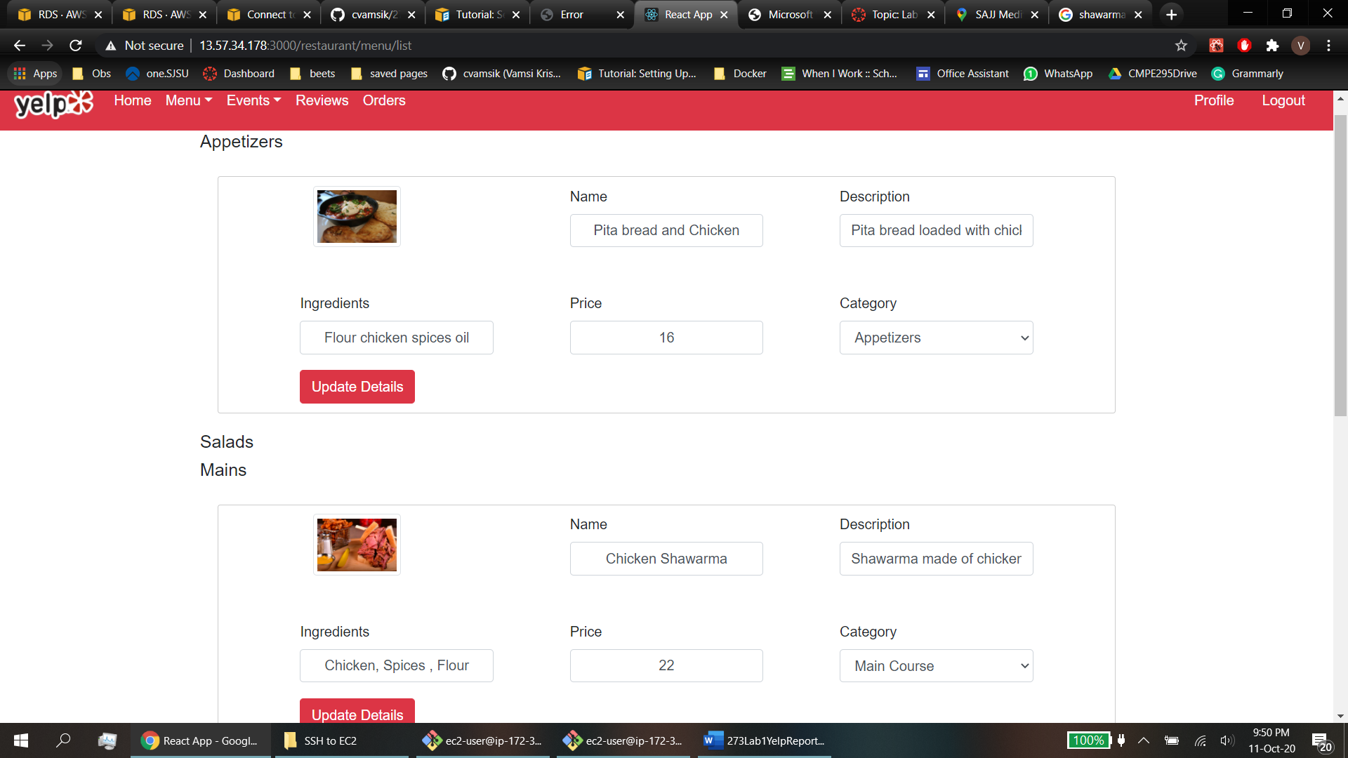

Events View:

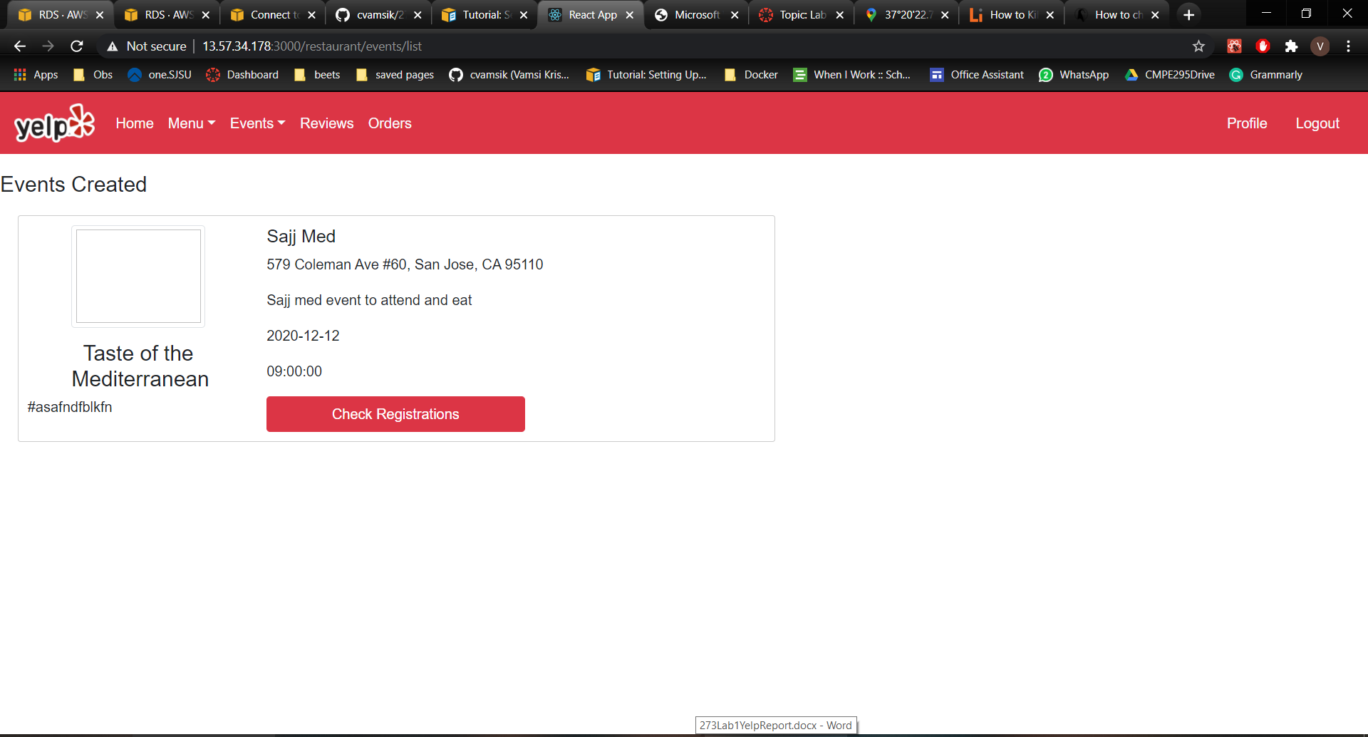

Customer Home:



Restaurant Search:

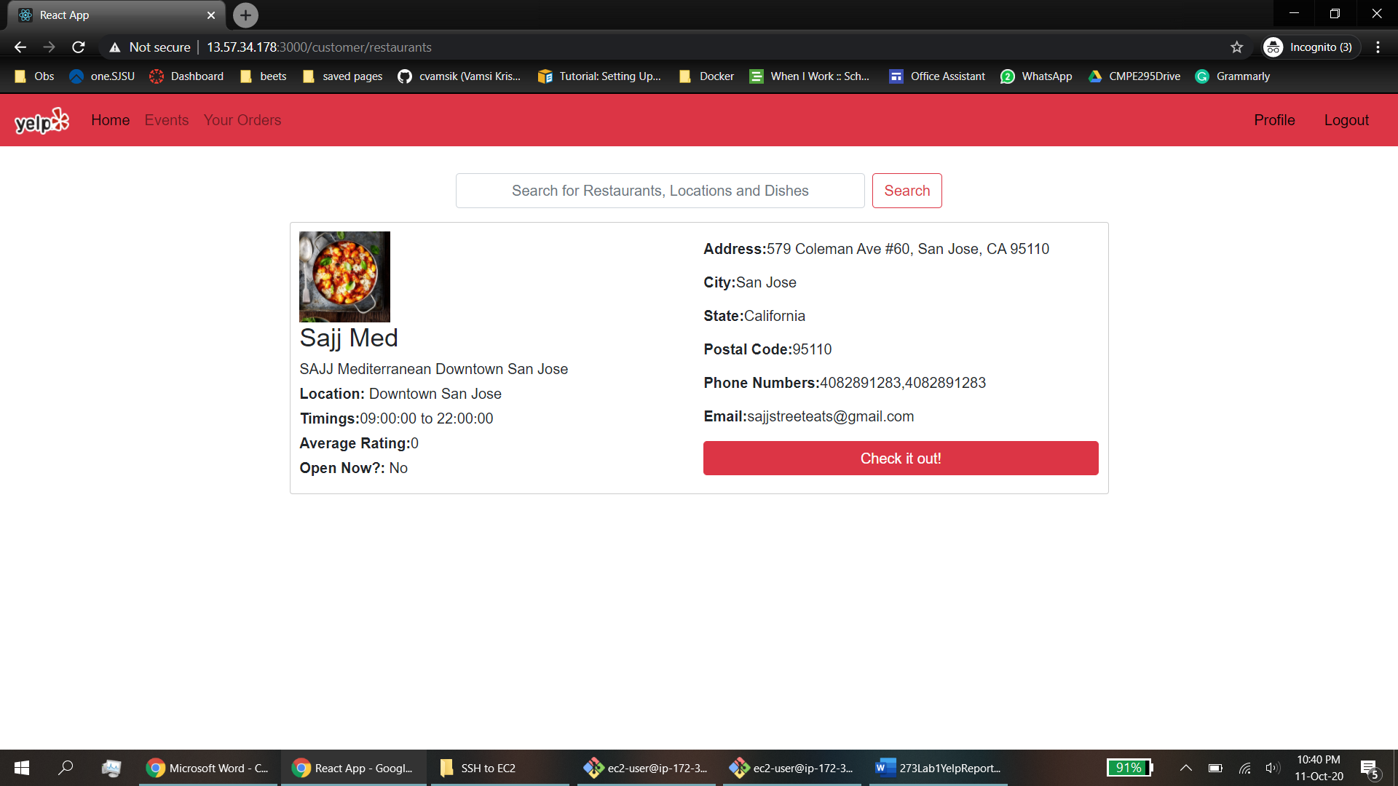

Orders:

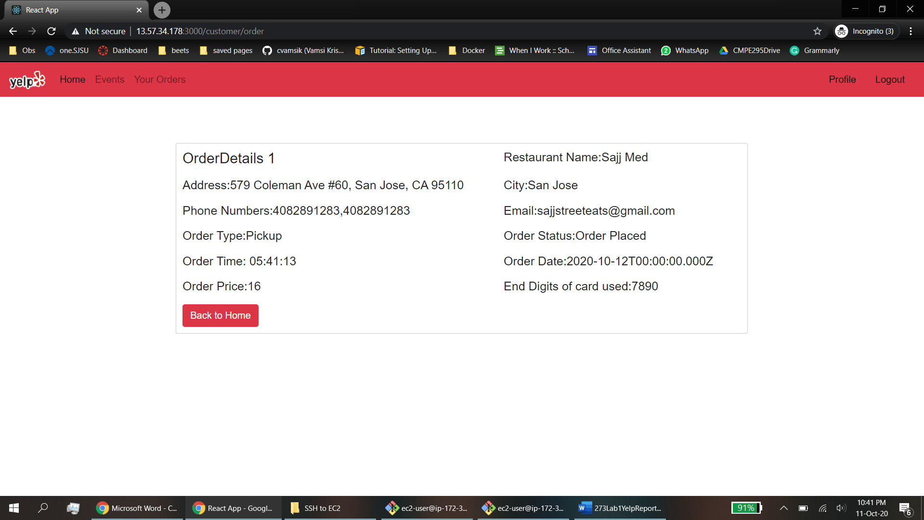

o Performance: What was performance? Analyze results and explain why you are getting those results.

The performance is measured with the time and the throughput tested against the servers. The throughput linearly increases with the increase in the user count without the pooling and is pretty constant with the pooling.

o Git Commit history – screen capture

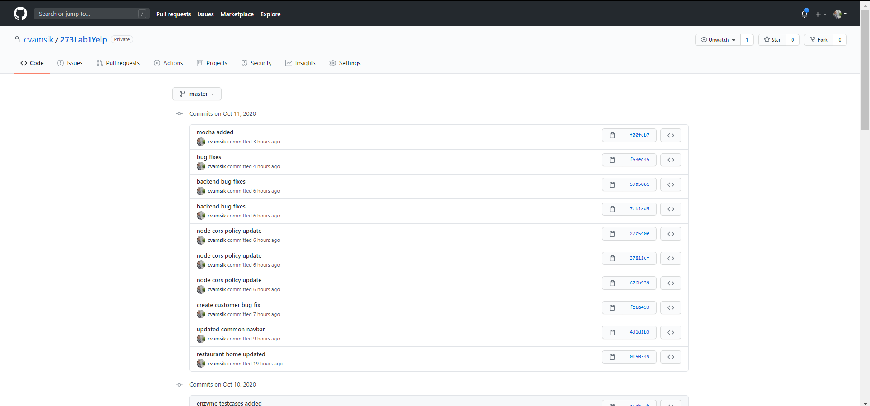

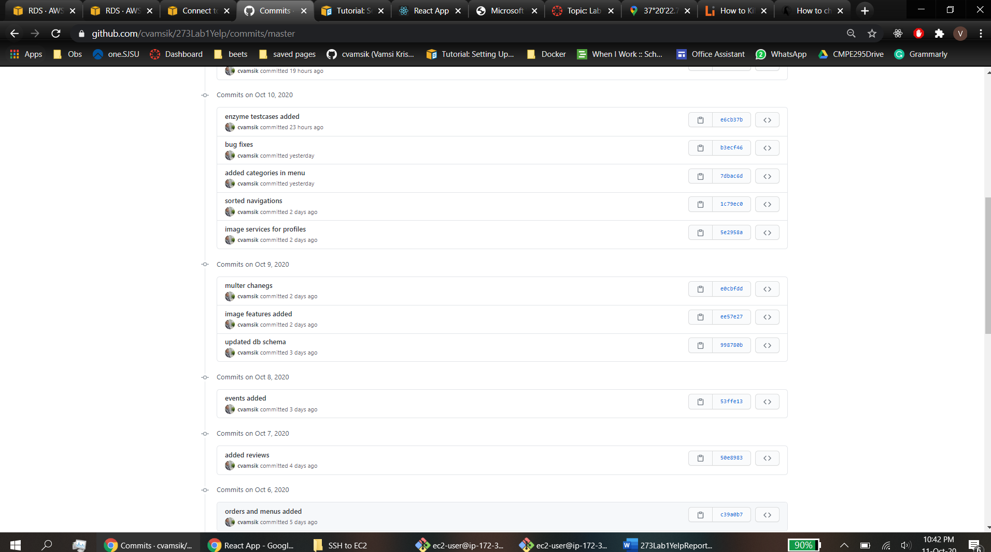

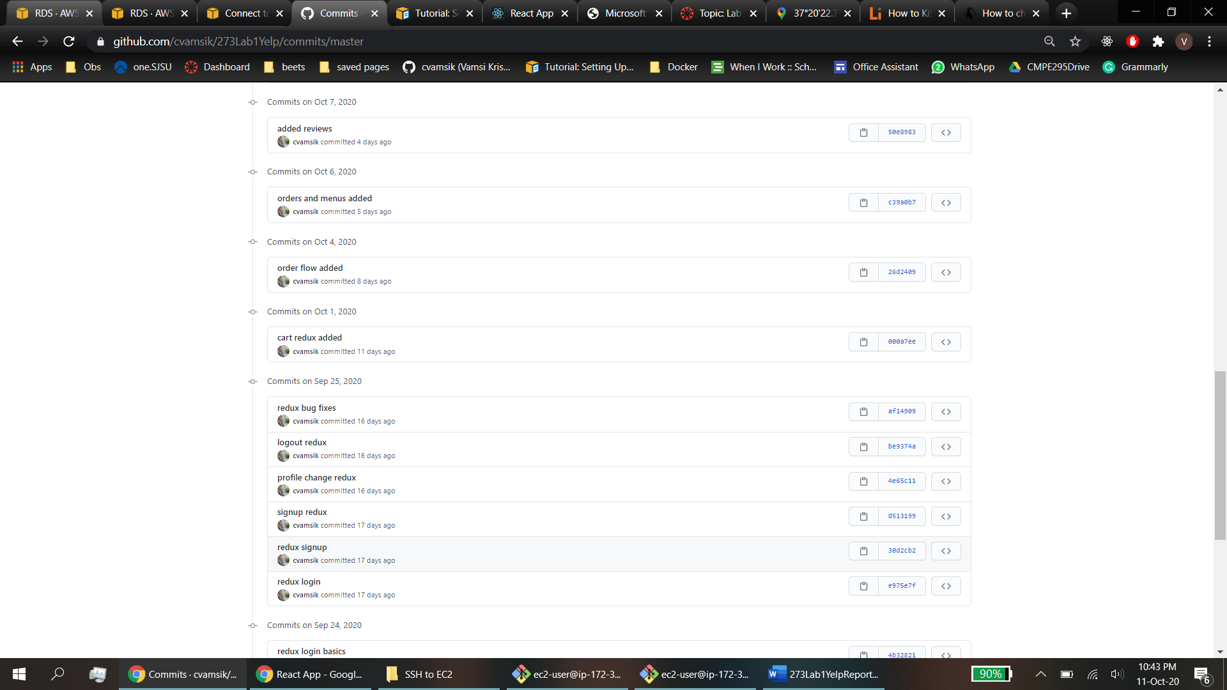

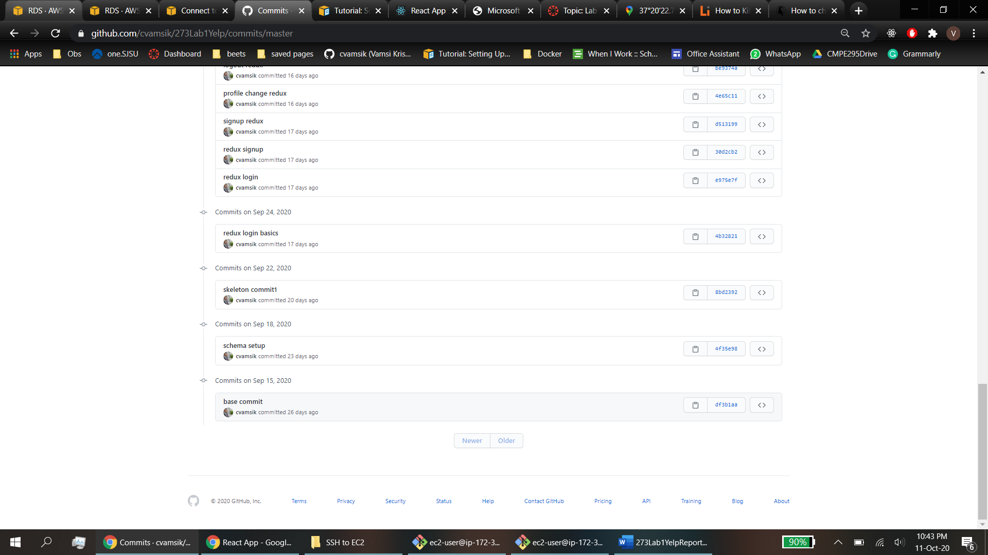

o Answers to the questions.

**Testing**

1. Testing of the backend server should be done using JMeter and Mocha.

2. Enzyme should be used to test at least 3 views/pages.

Enzyme Test:

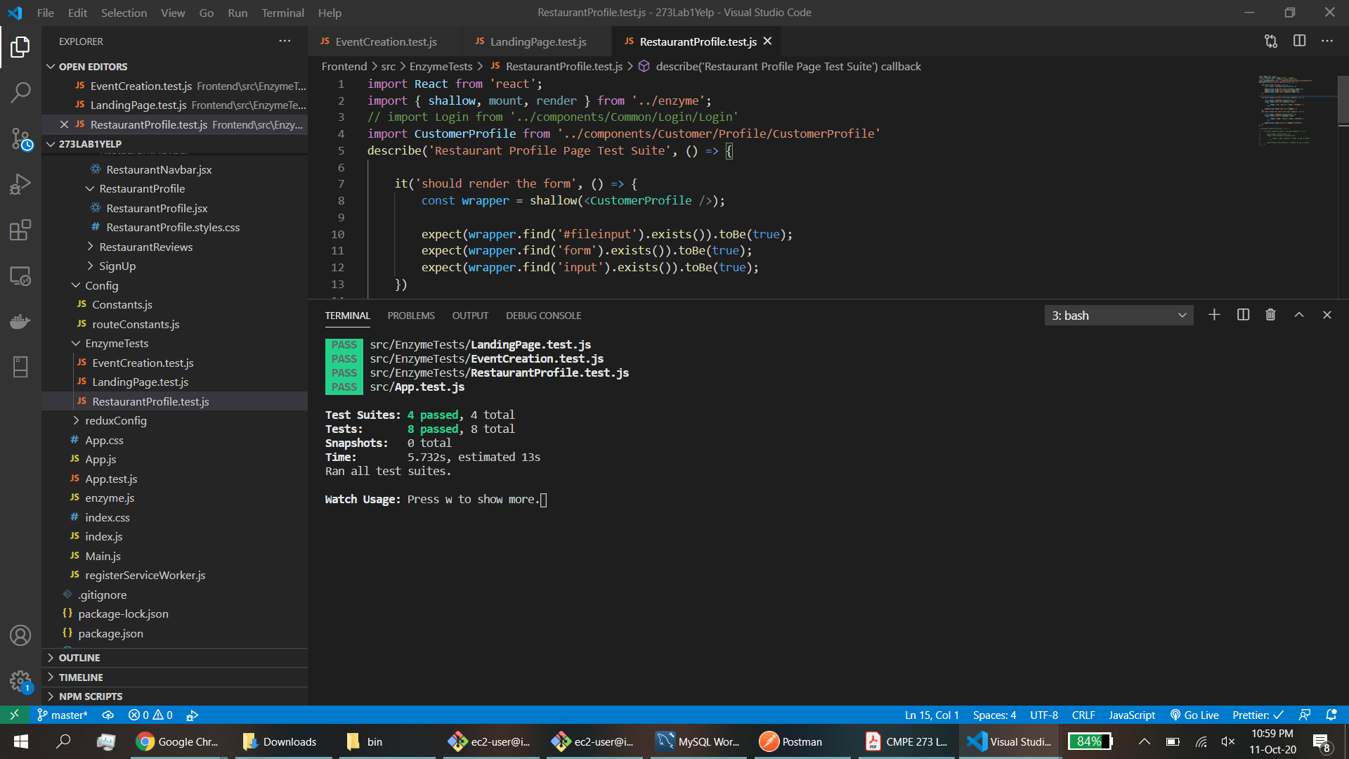

* • Following tasks to be tested using JMeter:

Test the server for **100, 200, 300, 400 and 500 concurrent users** with and without connection pooling. Draw the graph with the average time and include it in the report.

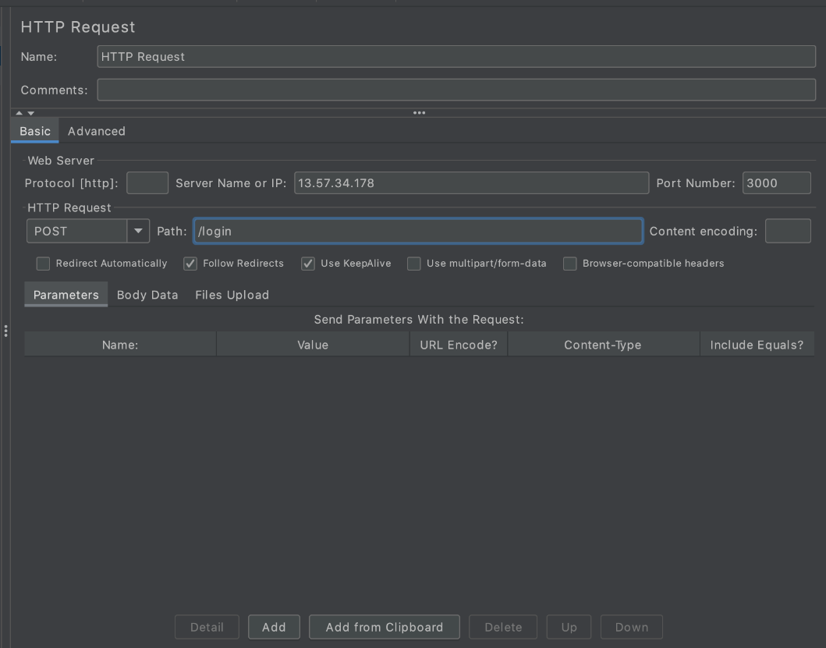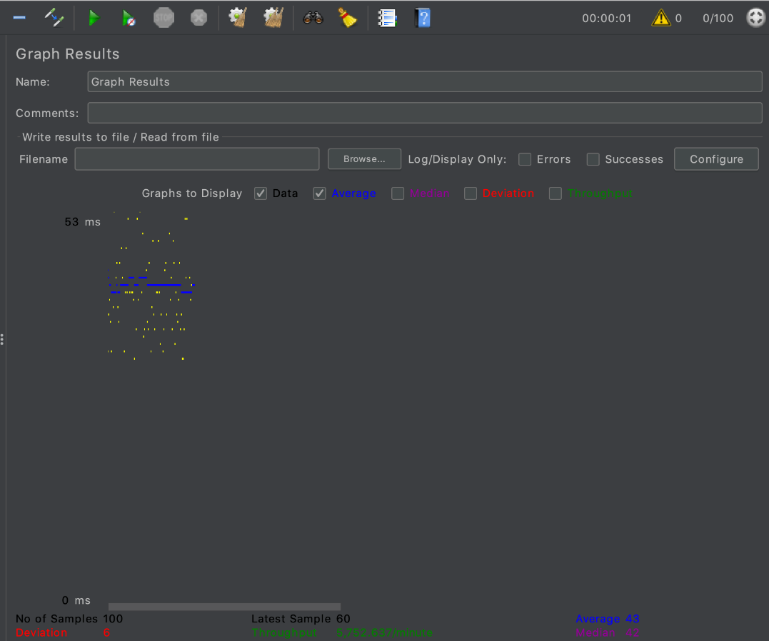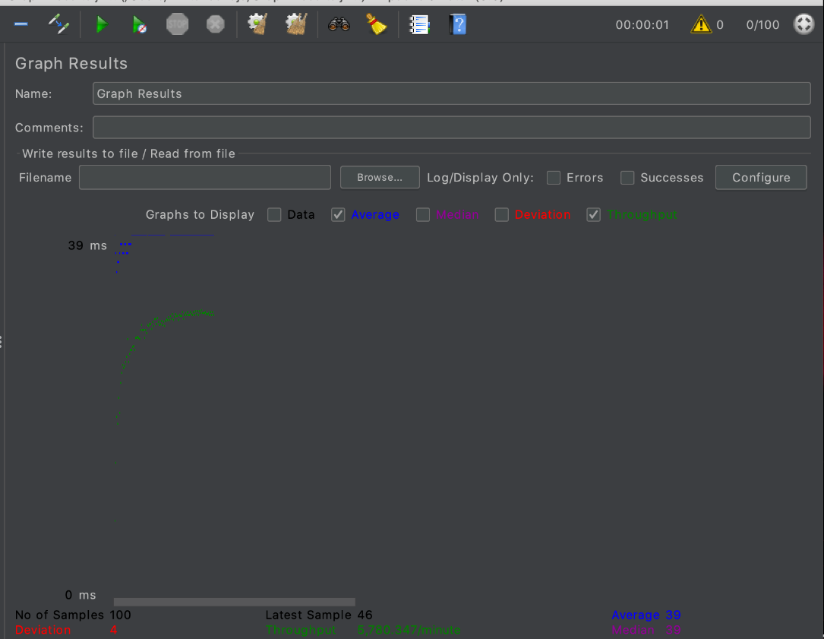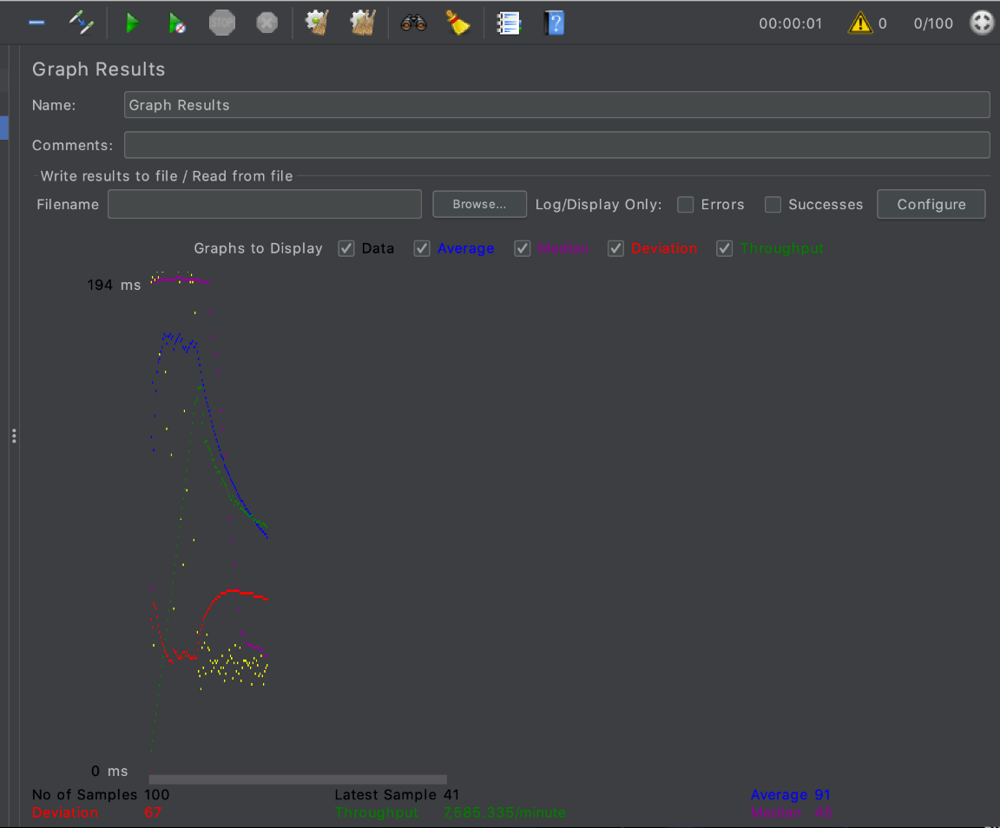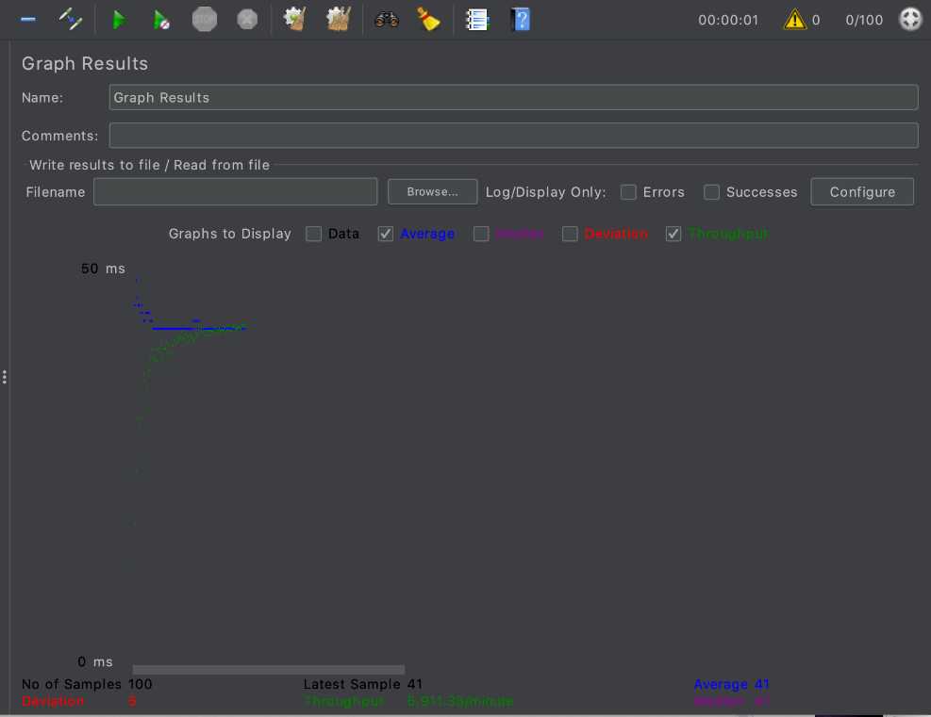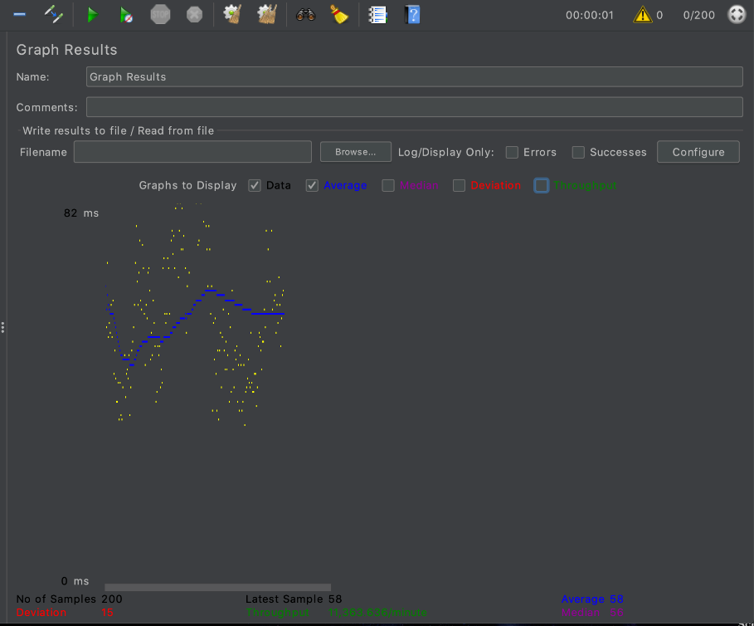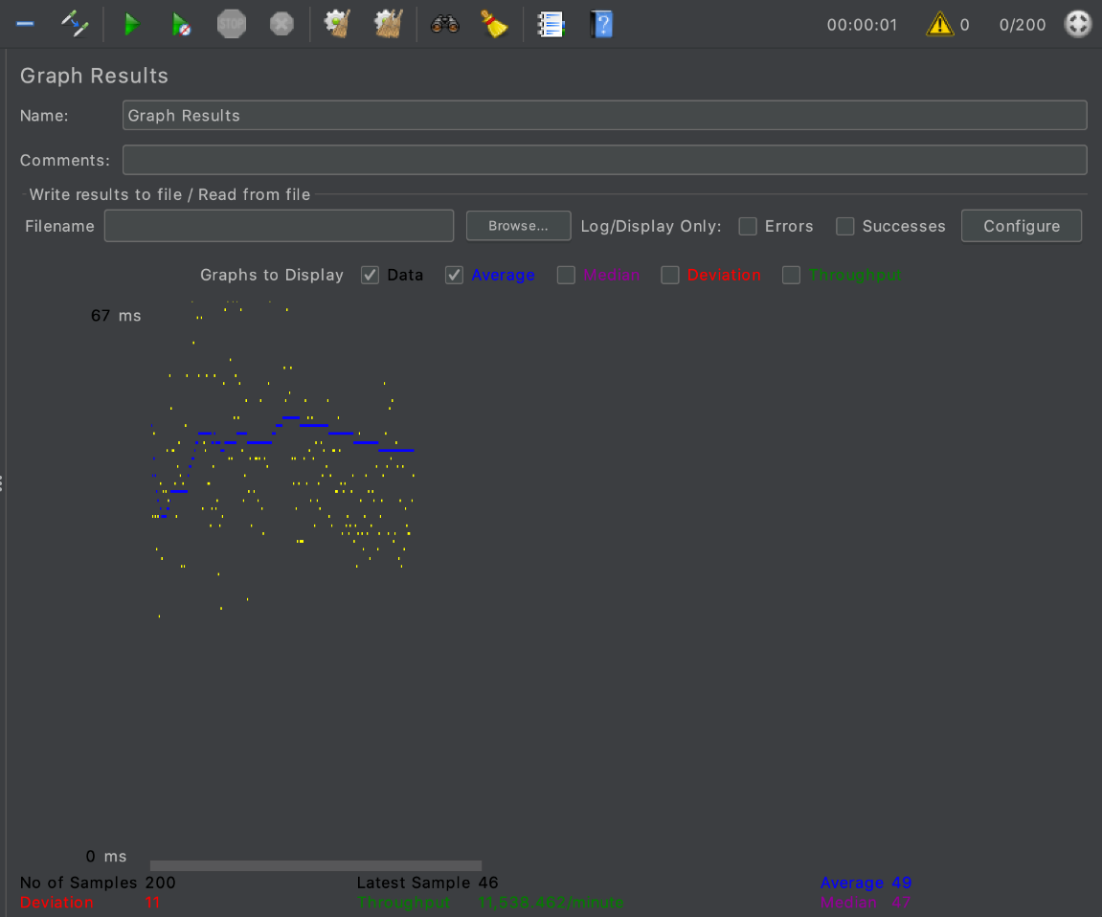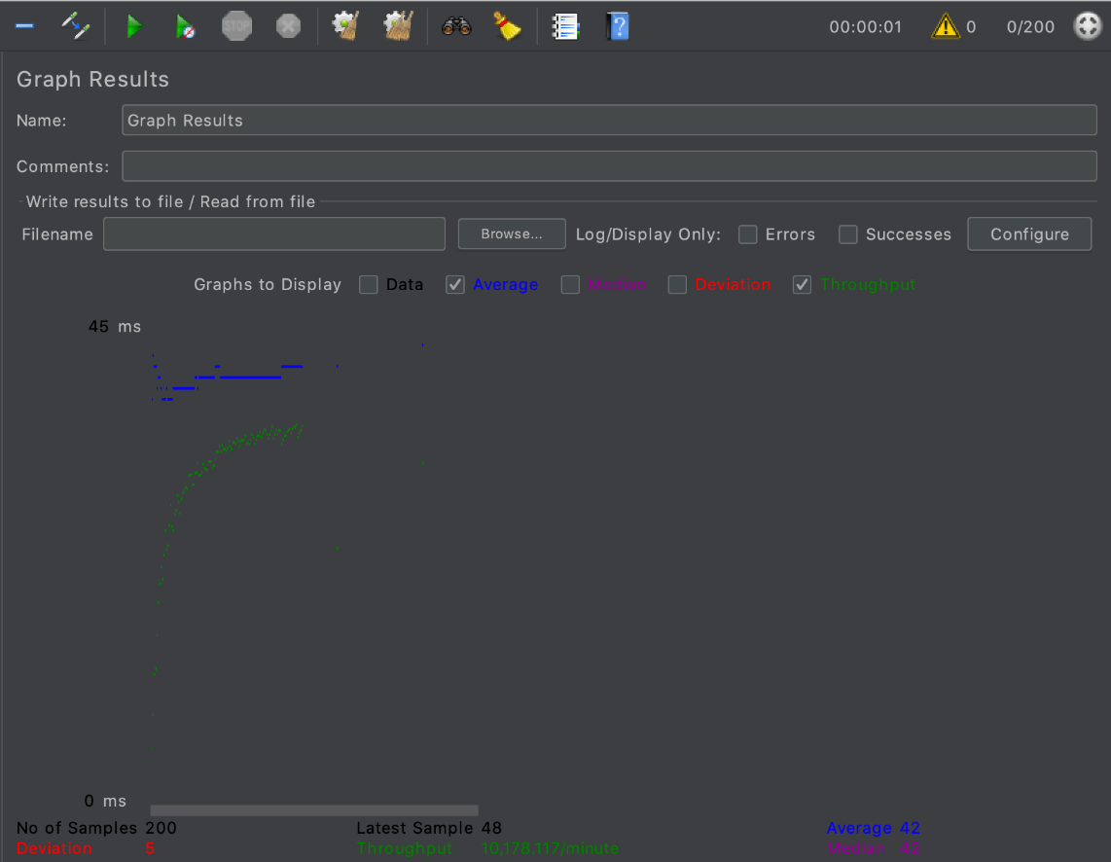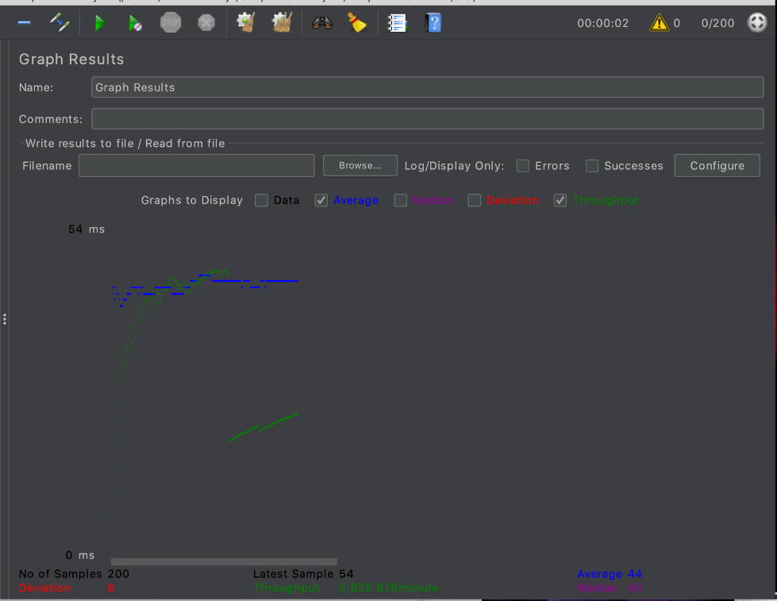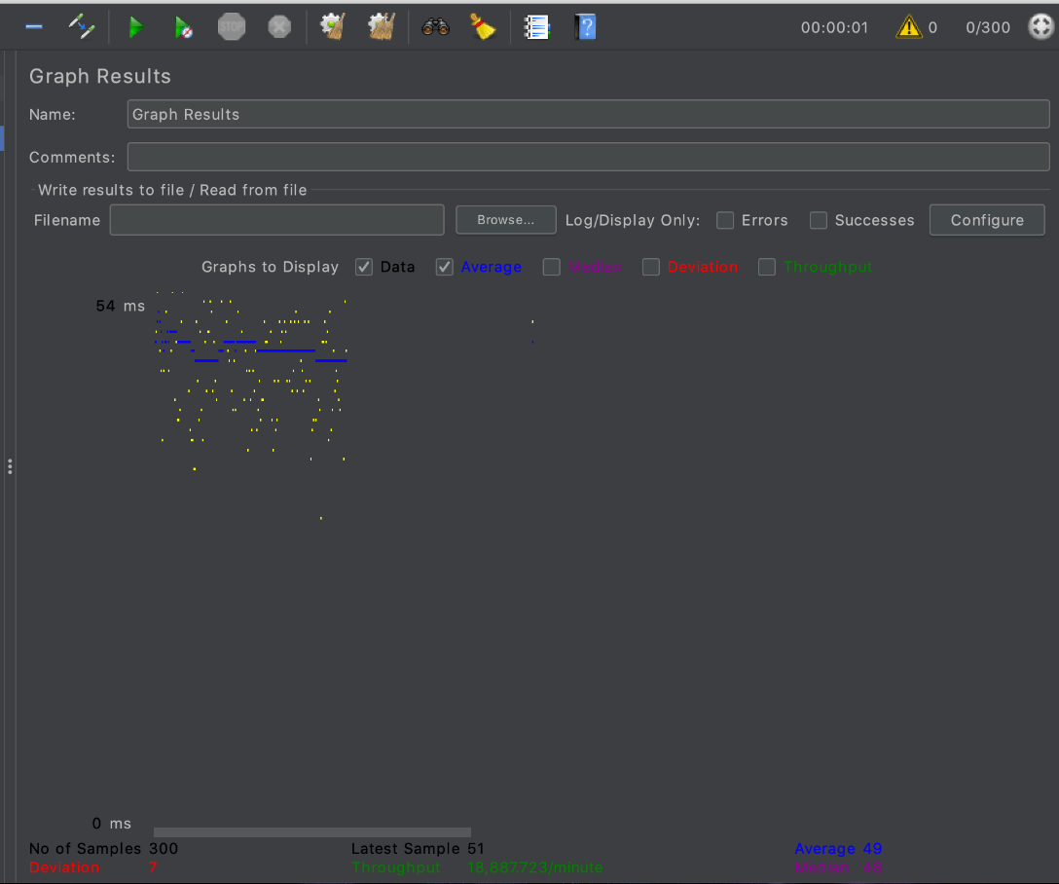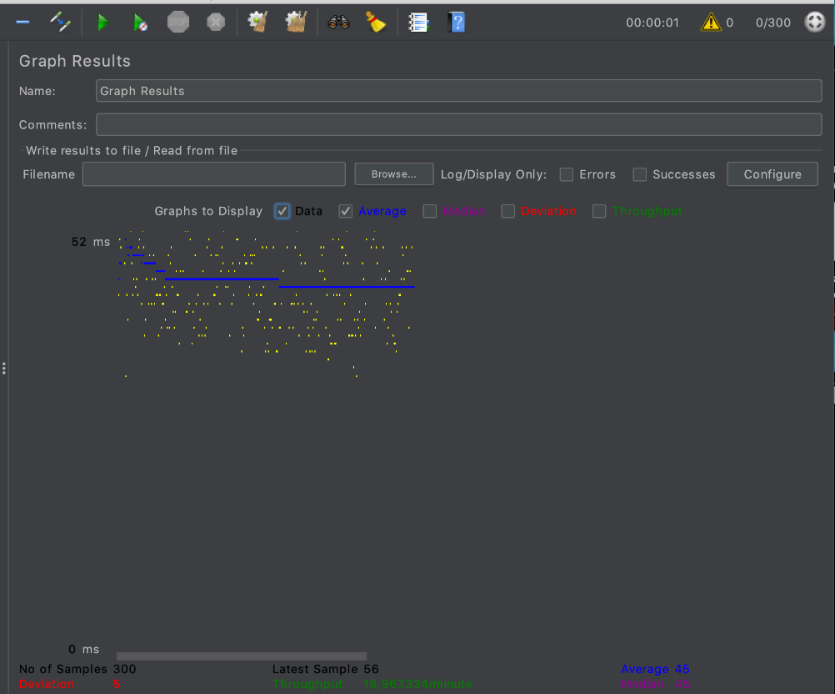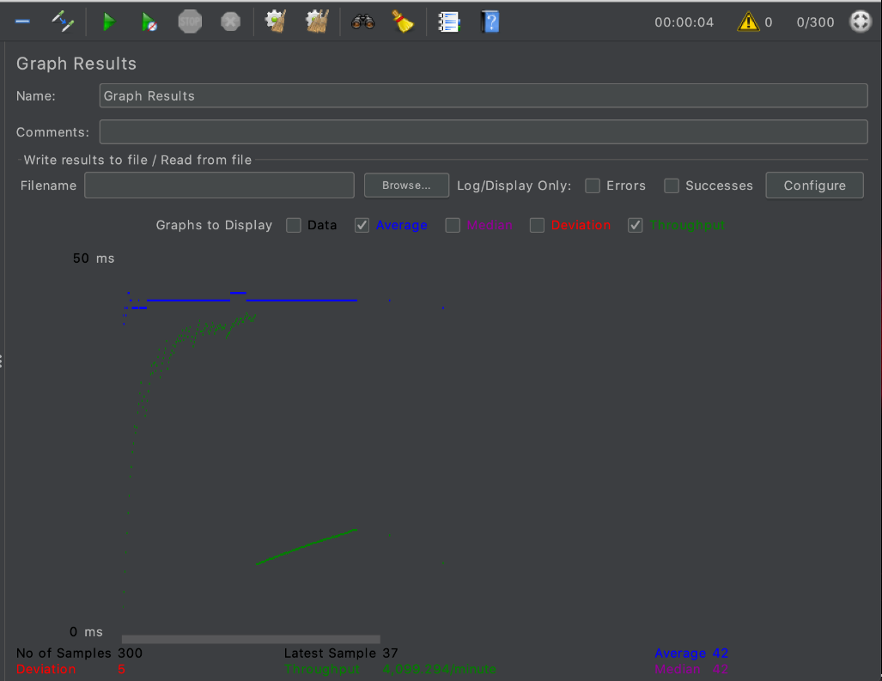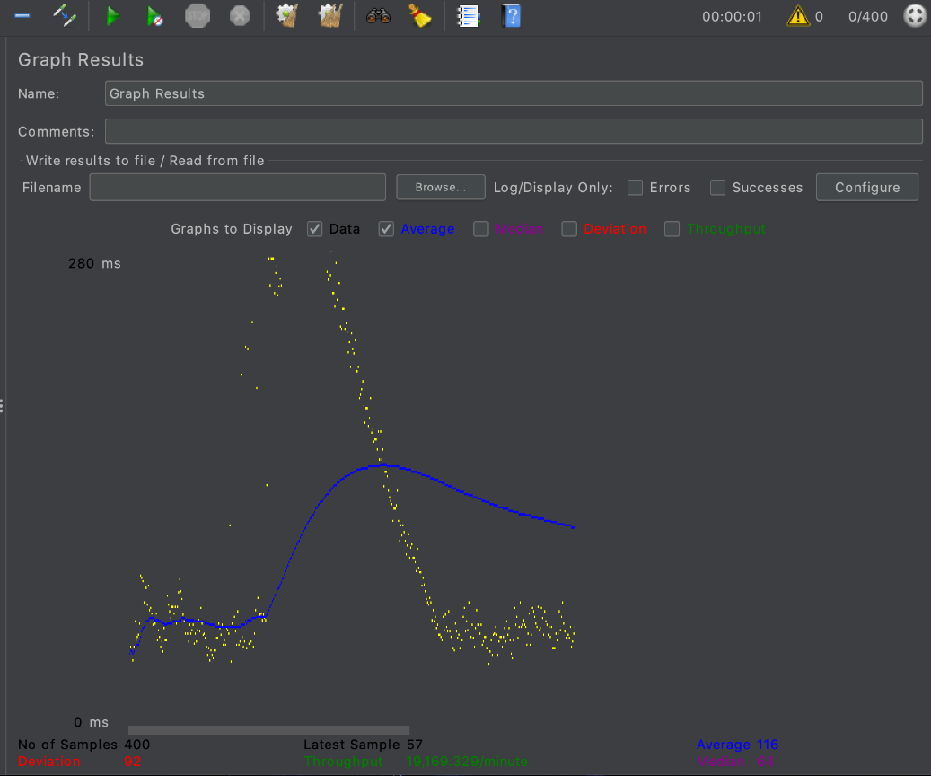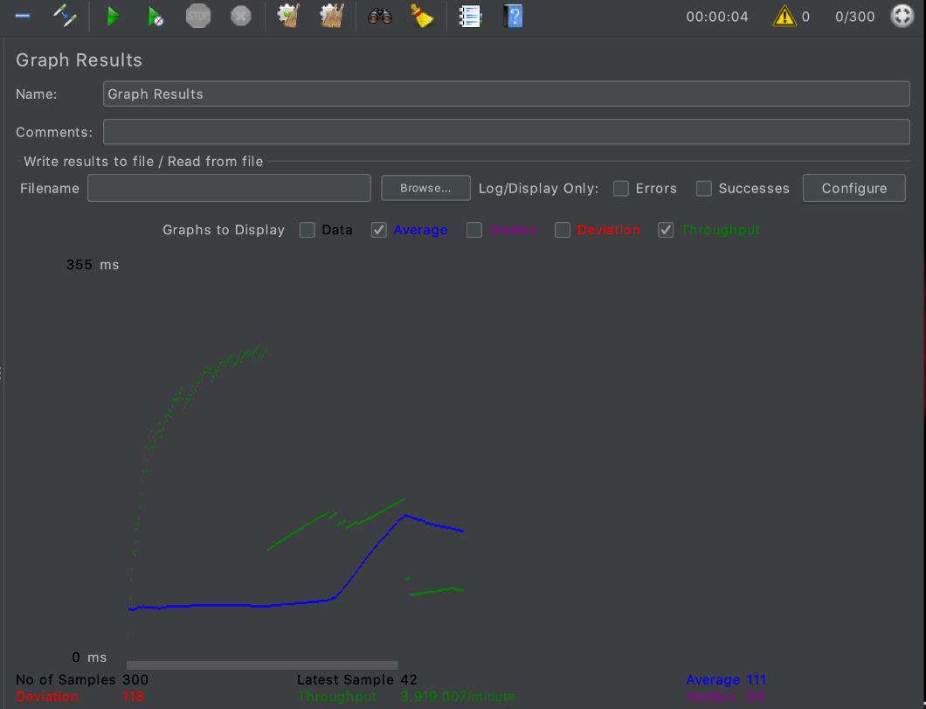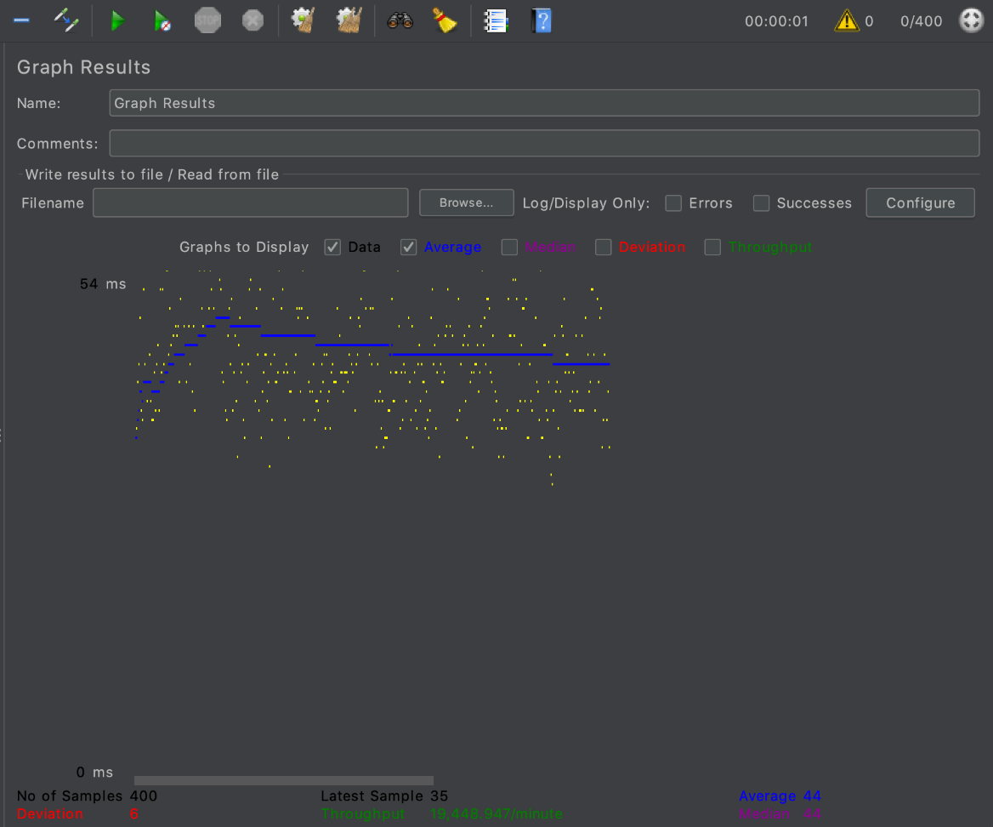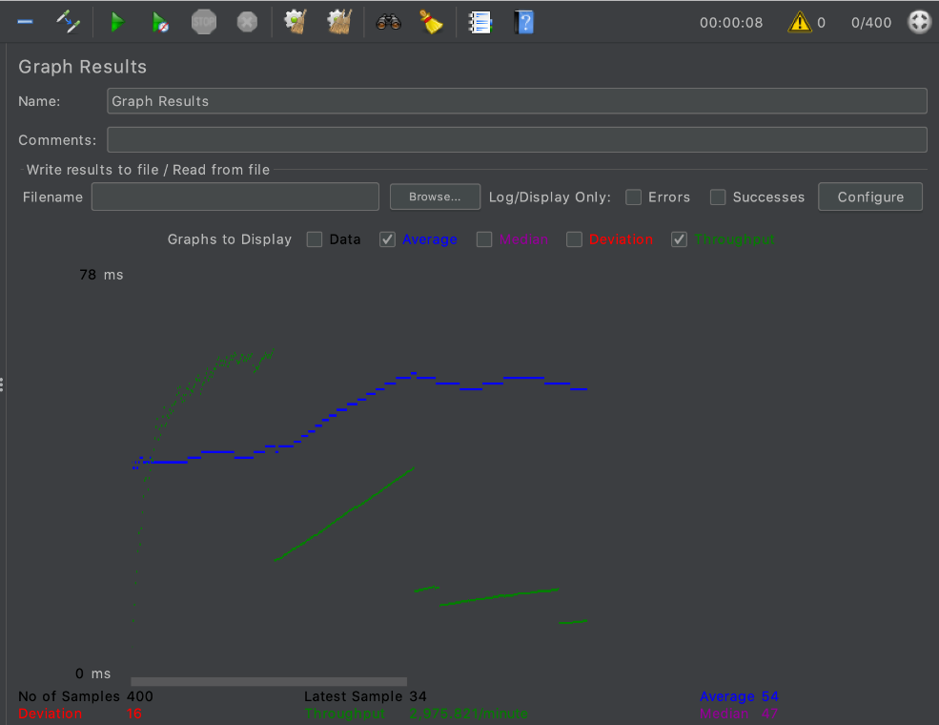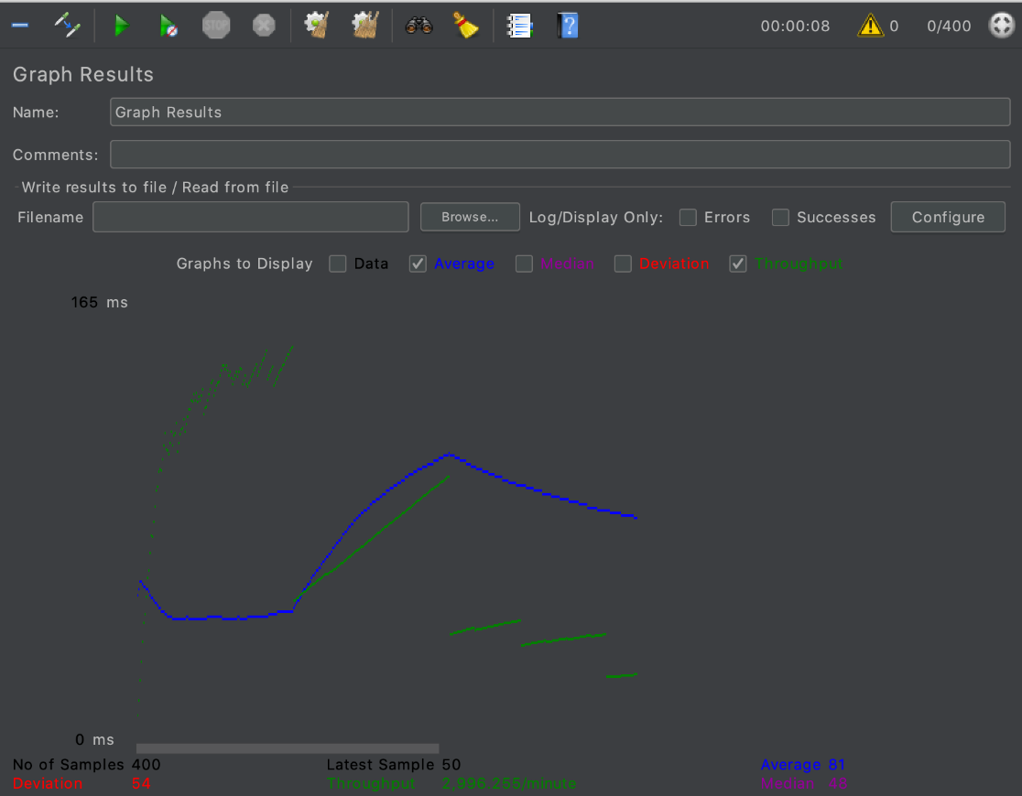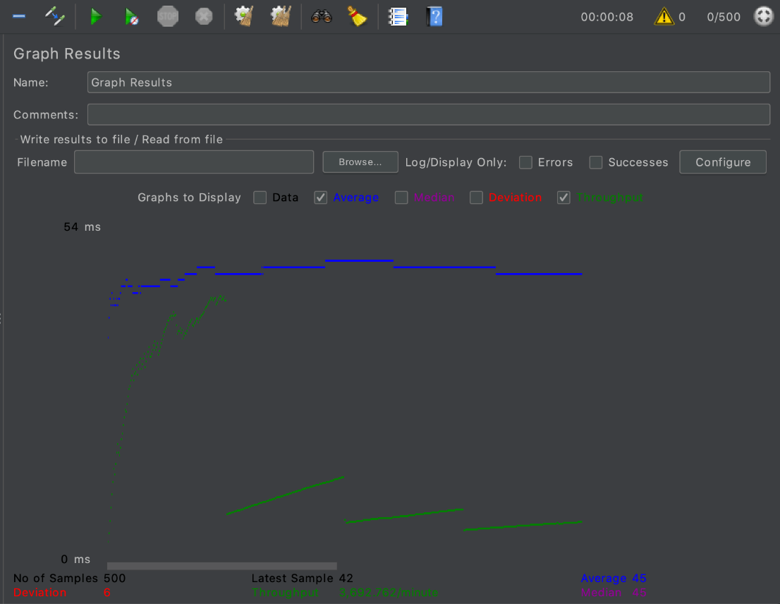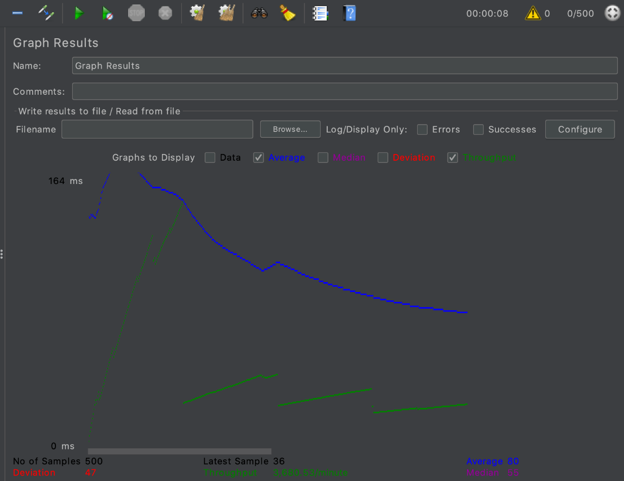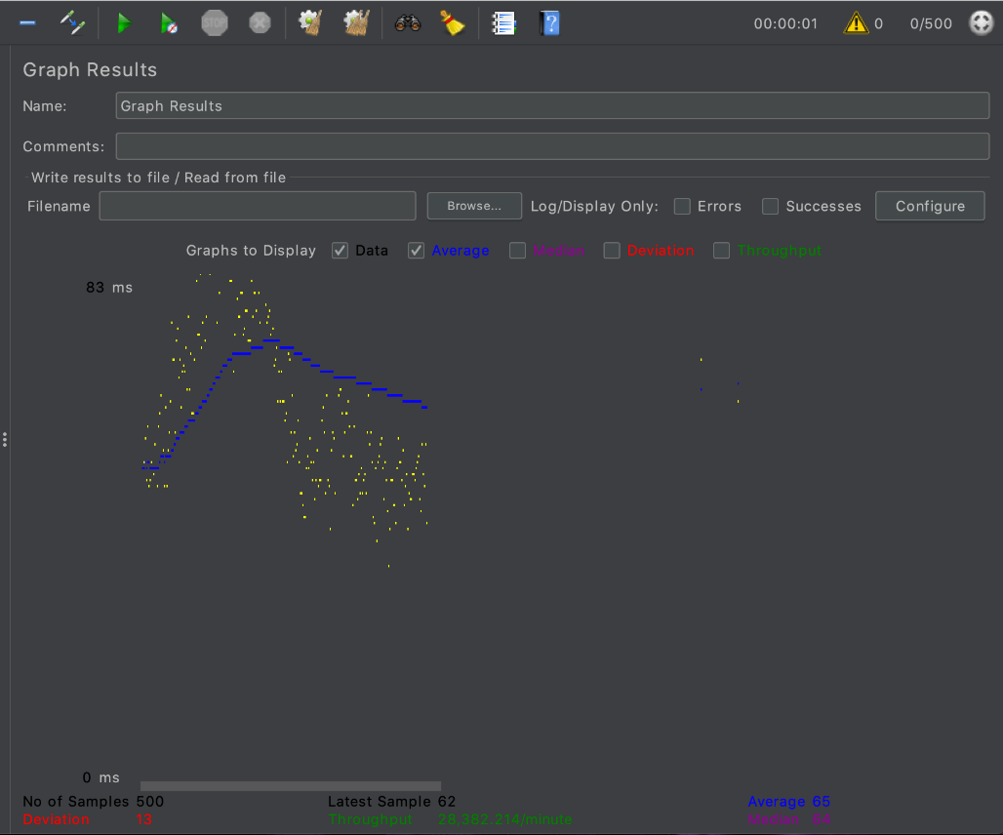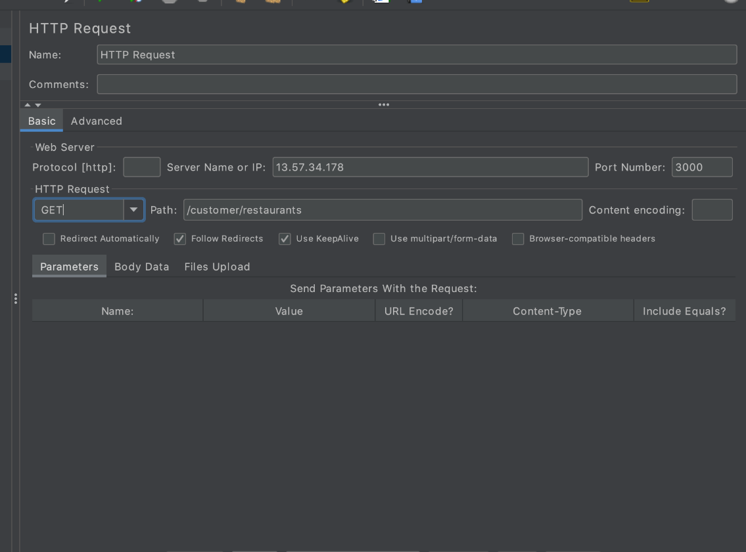

* • Following tasks to be tested using Mocha:

Implement five randomly selected REST web service API calls using Mocha. Display the output in the report.

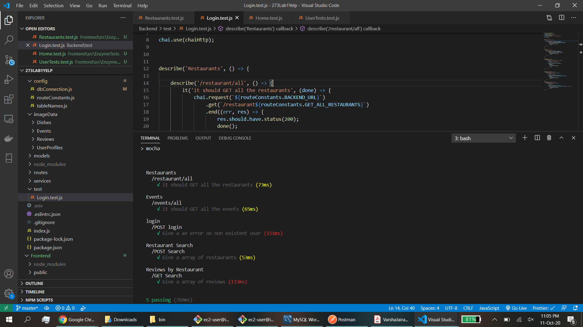

**Questions**

1. Compare the results of graphs with and without in-built mysql connection pooling of database. Explain the result in detail and describe the connection pooling algorithm if you need to implement connection pooling on your own. (3 pts)

Without the pooling, the connections take longer as the sharing of the existing connections Is not possible. There is a linear increase in the result with the increase in input user count without the pooling while the graph slopes very slowly with the pooling enabled.

A custom pooling algorithm can be created using the stack data structure, by pushing and popping a connection object whenever requests are made.

2. What are the ways to improve SQL Performance? List at least 3 strategies. Explain why those strategies improve the performance. (2 pts)

SQL performance can be improved by Normalization, Reduction in Joins usage, Indexing.

Normalization will eliminate the redundant columns and hence decrease the database size, while improving th e query efficiency.

Joins will have to merge multiple table and will increase the time for each select query. The DB will first search for the tables and then filter out. Hence a reduced joins usage will help the DB speed.

Indexing will create an index for the tables , increasing the search capabilities and throughput of the DB overall.